SAFE SLEEPING FOR BABIES ADVICE

* The safest place for baby to sleep is in their own cot, crib or moses basket
* Babies should sleep in the same room as the adult who is caring for them, for every sleep, for at least the first 6 months of life

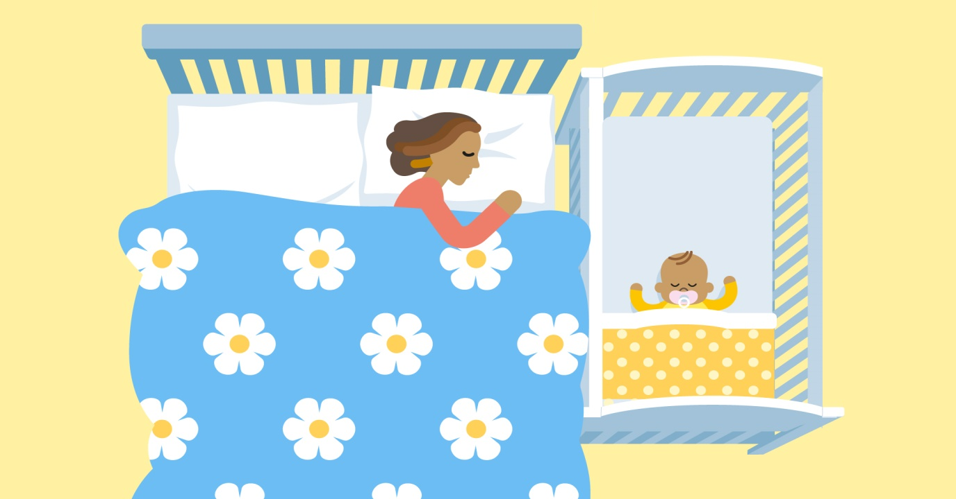

THERE ARE SOME CIRCUMSTANCES IN WHICH BED SHARING WITH YOUR BABY CAN BE VERY DANGEROUS:

If either you or your partner smokes, even if you do not smoke in the bedroom, **NEVER** share a bed with your baby.

|  |  |
| --- | --- |
| * If you are extremely tired, **NEVER** share a bed with your baby. * If your baby was born prematurely (37 weeks or less) or was born at a low weight (2.5kg or 5½ lbs or less) **NEVER** share a bed with your baby. * **NEVER** sleep on a sofa or armchair with your baby, this can increase the risk of death by 50%. * If either you or your partner has drunk alcohol or taken drugs, including medications that may make you drowsy, **NEVER** share a bed with your baby. Drinking alcohol/taking drugs before bed can make you fall into a deep sleep and become less responsive. | baby sleeping on the chest of a lady on a sofa. There is a red cross across the picture |

# SPEAK TO YOUR MIDWIFE OR HEALTH VISITOR IF YOU NEED SUPPORT OR MORE INFORMATION