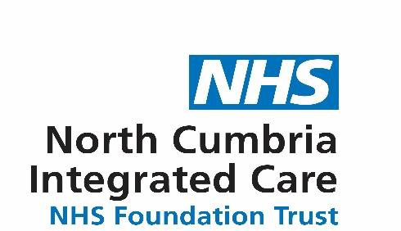
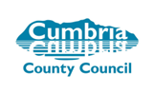
SOUTH LAKES
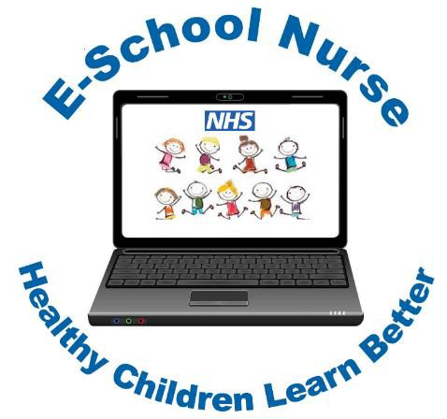
E-School Nurse
Video Clinics

Online health support and advice for parents, carers and professionals, supporting children and young people aged 5-19 years old.

MONDAY AFTERNOONS
1 – 4pm

You will be able to talk to the nurse over a live video link that is private, secure, confidential and convenient for you. In consultation with you, the nurse will assess the child or young person’s health problem and provide you with the support and advice needed.

For more information on the E-School Nurse video clinic
Please visit: www.cumbria.gov.uk/ph5to19

You can telephone for an appointment
0300 30 34 365

NCIC/E-SN/Poster.SL/062020 | APPENDIX 12

