Type 2 diabetes is a very serious health condition but there are lots of things you can do to reduce your risk or even stop you getting it.

If you are at high risk of developing Type 2 diabetes- Also Known as At Risk of Type 2 Diabetes or Non-diabetic hyperglycaemia you may be eligible for referral to your local Healthier You service.

The Healthier You: NHS Diabetes Prevention Programme (NHS DPP) was officially launched in 2016 to support people who are at high risk of developing Type 2 diabetes.

This NHS-funded programme can support you to make simple changes to your diet, weight management and physical activity levels.
They are easy to incorporate into your everyday routine and can significantly reduce your risk of diabetes-related health problems.

Find out how you can be referred to Healthier You :

https://www.morecambebayccg.nhs.uk/your-health/diabetes/national-diabetes-prevention-programme

Pre-diabetes
Many people have blood sugar levels above the normal range, but not high enough to be diagnosed as having diabetes.
This is sometimes known as Pre-diabetes or non-diabetic hyperglycaemia. If your blood sugar level is above the normal range, your risk of developing full-blown diabetes increases.
It's very important for diabetes to be diagnosed as early as possible because it will get progressively worse if left untreated.

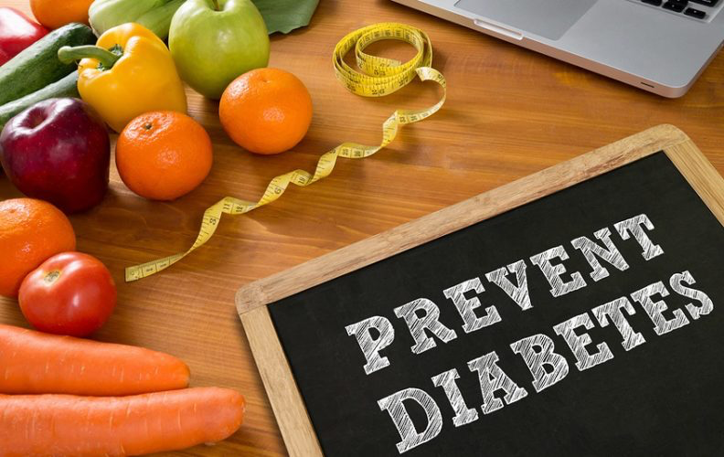
PREVENT DIABETES

When to see a doctor
Visit your GP as soon as possible if you experience the main symptoms of diabetes, which include:

- Feeling very thirsty
- Peeing more frequently than usual, particularly at night
- Weight loss and loss of muscle bulk
- Itching around the penis or vagina, or frequent episodes of thrush
- Cuts or wounds that heal slowly
- Blurred vision

Type 1 diabetes can develop quickly over weeks or even days.
Many people have type 2 diabetes for years without realising because the early symptoms tend to be general.

Causes of diabetes
The amount of sugar in the blood is controlled by a hormone called insulin, which is produced by the pancreas (a gland behind the stomach).

When food is digested and enters your bloodstream, insulin moves glucose out of the blood and into cells, where it's broken down to produce energy.

However, if you have diabetes, your body is unable to break down glucose into energy. This is because there's either not enough insulin to move the glucose, or the insulin produced does not work properly.

There are no lifestyle changes you can make to lower your risk of type 1 diabetes.

YOU CAN HELP manage type 2 diabetes through healthy eating, regular exercise and achieving a healthy body weight.

Living with diabetes
If you're diagnosed with diabetes, you'll need to eat healthily, take regular exercise and carry out regular blood tests to ensure your blood glucose levels stay balanced.
You can use the BMI healthy weight calculator to check whether you're a healthy weight.
You can find apps and tools in the NHS Apps Library to help you manage your diabetes and have a healthier lifestyle.

People diagnosed with type 1 diabetes also require regular insulin injections for the rest of their life.

As type 2 diabetes is a progressive condition, medicine may eventually be required, usually in the form of tablets.

